NPA URCHIN Open Seminar, Project Meeting and Ministry Meeting
Reykjavik, Ireland,
3th – 5th October, 2016

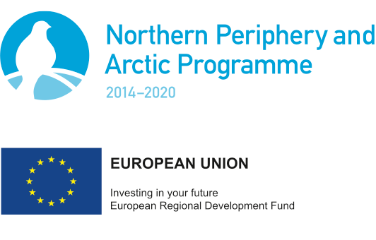

Location: Marine Research Institute,
Skúlagata 4
Reykjavik
Iceland

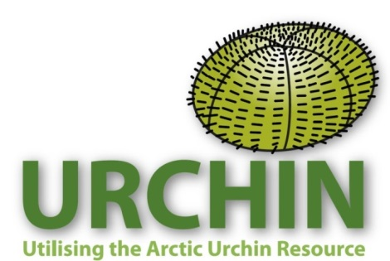

- Iceland Open Seminar: Mon 3rd April

Location: Marine Research Institute, Lecture theatre
Skúlagata 4
Reykjavik, Iceland

Outline of Seminar:

- Welcome and introduction to the Northern Periphery and Arctic program and the URCHIN Project (Phil James, Nofima, Norway)
- Sea urchin hatchery production and reseeding (Colin Hannon, Galway Mayo Institute of Technology, Ireland)
- Sea urchin roe enhancement (Phil James, Nofima, Nofima)
- Canada’s framework for providing scientific advice for the management of new and developing invertebrate fisheries (case study: sea cucumbers in British Columbia (Janet Lochead, Fisheries and Oceans Canada)
- Open discussion around the sea urchin industry in the NPA, issues related to reseeding, hatchery production, roe enhancement and fisheries management.

Project Partner Participants:

Phil James (Nofima, Norway)
Colin Hannon (GMIT, Ireland)
Janet Lochead (Fisheries and Oceans Canada)
Guðrún Þórarinsdóttir (MRI, Iceland)
Guðmundur Stefánsson (Matis, Iceland)
Tor Evensen (Nofima, Norway)
Sten Siikavuopio (Nofima, Norway)
Bente Johansen (Nofima, Norway)
Svein Åge Rønning (Arctic Caviar AS, Norway)

Non Project Partner Participants:

Tumi Tomossan UNU- FTP Iceland
Thor Asgersen UNU-FT Iceland
Sigrdur Ingvarsdottir United nations University, Fisheries training program Iceland
Agnes Eydal MFRI Iceland
Sun Xiang Shan Dalian Ocean University China
He Yunhai Dalian Ocean University China
Giang Nguyen Nha Tang University Vietnam
Ovaldo Costa National Institute of Research Fisheries Angola
Keegan Slinger Aquaculture Department Trinidad & Tobago
Philipo Mayula Fishermans Division Tanzania
Momoduu Saidyleigh UNUFTP Gambia
Nadia McNeish Ministry and Agriculture & Fisheries Jamaica
Funice Asamoah University of Ghana (Dept. Marine and Fish) Ghana
Martin Mutuga Ministry of Fisheries Kenya
Britney Kasmiran SUVVEB Uni. Suriname
Isaton Tamba Department of Fisheries Gambia
Carina Fennended University CV Cape Verde
Sipokazi Mayalo Depart. of Ag., Forestry and Fisheries South Africa
Ssempijja Drake Makerere University Uganda
Khairudin Isman Marine and Fisheries Ministry Indonesia
Esther Pinilcco Ministry of Fisheries and Marine Namibia
Ady Sabana Ministry of marine Affairs & Fisheries Indonesia
Morfow Paul Nkeze Ministry of Livestock and Fisheries & Animal Industries Cameroon
Elizabeth Forgalgo Ministry of Livestock and Fisheries & Animal Industries Cameroon
Janeth Rukanda Ministry of Agriculture, Livestock and Fisheries Tanzania

Total number of Participants attending Seminar: 35
Number of countries represented at Seminar: 23

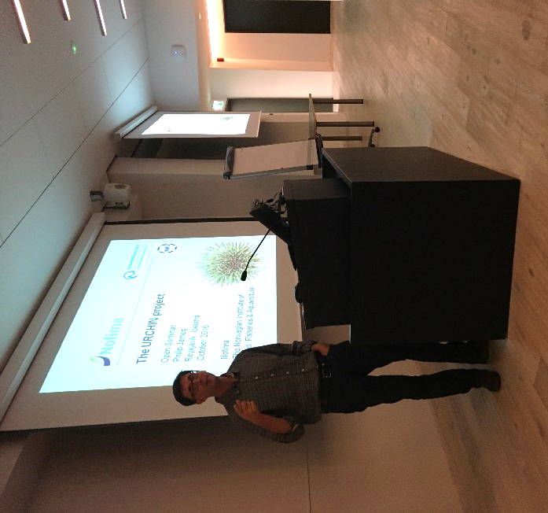

Philip James from Nofima (Norway) introduces the URCHIN project
at the Open Seminar held in Reykjavik.

Project meeting: Tuesday 4th October

Location: Marine Research Institute, Meeting Room
Skúlagata 4
Reykjavik, Iceland

Project Participants:
Phil James (Nofima, Norway)
Colin Hannon (GMIT, Ireland)
Janet Lochead (Fisheries and Oceans Canada)
Guðrún Þórarinsdóttir (MRI, Iceland)
Guðmundur Stefánsson (Matis, Iceland)
Tor Evensen (Nofima, Norway)
Sten Siikavuopio (Nofima, Norway)
Bente Johansen (Nofima, Norway)
Svein Åge Rønning (Arctic Caviar AS, Norway)
Ólafur Ásmundsson (Thorisholmi ehf, Iceland)

Attend by skype:
Royal Greenland (Greenland)

Minutes of the meeting:
- Welcome, overview and introduction by Coordinator.
- An overview of the NPA conference and lead partner meeting held in Akureyri the previous week were presented.
- Bente (Project financial coordinator) discussed financial and project reporting and all partners were given instructions on finalizing the report for the first period (0-6 months). It was reiterated that this is now a critical task and must be finished ASAP.
- Update and current status for each Project partner:
- Nofima (Norway)
- MRI and Thorsholmi (Iceland)
- GMIT (Ireland)
- Arctic Caviar (Norway)
- Matis (Iceland)
Skype session:
- Royal Greenland (Greenland)
- Work Package 1-6 discussion and overview
- Deliverables in each WP
- Outputs from each WP
- Who is participating in WP and when outputs are due
(A revised WP list including completed deliverables and future deliverables is attached to this report)
- The next project meeting was discussed with Janet Lochead from Fisheries and Oceans Canada inviting the Project to hold the next meeting in Vancouver, Canada. Phil said he would approach the NPA Secretariat to see if this was possible. Other alternatives would be Norway or Galway.
- Project dinner

Iceland Ministry Meeting: Wed 5th October

Location: Marine Research Institute, Lecture theatre
Skúlagata 4
Reykjavik, Iceland

Project Participants:
Phil James (Nofima, Norway)
Colin Hannon (GMIT, Ireland)
Janet Lochead (Fisheries and Oceans Canada)
Guðrún Þórarinsdóttir (MRI, Iceland)
Guðmundur Stefánsson (Matis, Iceland)
Tor Evensen (Nofima, Norway)
Sten Siikavuopio (Nofima, Norway)
Svein Åge Rønning (Arctic Caviar AS, Norway)
Ólafur Ásmundsson (Thorisholmi ehf, Iceland)

Ministry participants:
(Ministry of Industries and Innovation, Department of resource management)
Hinrik Greipsson (Expert Fisheries Management)
Erna Jonsdottir (Expert in Law related to Fisheries Management)

Presentation and discussion points:

- Welcome by Guðrún Þórarinsdóttir from Marine Research Institute and a review of the Icelandic sea urchin experience (delivered by Guðmundur Stefánsson)
- Introduction to the Northern Periphery and Arctic program and the URCHIN Project (Phil James, Nofima, Norway)
- The sea urchin fishery in Ireland (Colin Hannon, Galway Mayo Institute of Technology, Ireland)
- Sea urchin fisheries management in NZ, a short review (Phil James, Nofima, Norway)
- A framework for providing scientific advice for the management of new
and developing invertebrate fisheries (Janet Lochead, Fisheries and Oceans Canada)
- Open discussion around the issues faced in Iceland and how some of the lessons learnt in other sea urchin fisheries from around the world could be applied in Iceland. This will enable fisheries managers to avoid over-exploitation of existing sea urchin fisheries, protect the rights of fishermen that have developed the current fishery and to enable the exploration and development of the fishery in other areas of Iceland.
- The meeting concluded with MRI, Matis and Thorisholmi agreeing to continue the discussion with Government representatives to provide an action plan for future sea urchin fishery management.
- The meeting concluded with a presentation and teste testing of urchins fished by Ólafur Ásmundsson (Thorisholmi ehf).

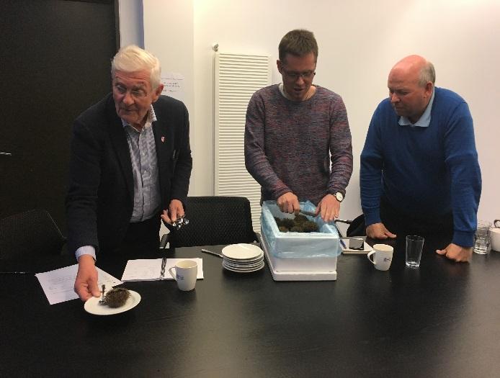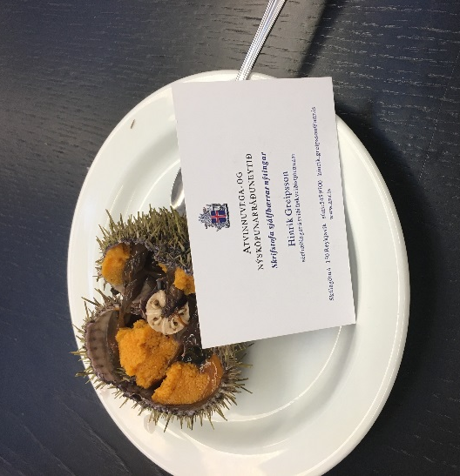

From left to right: Hinrik Greipsson (Expert Fisheries Management) from the Icelandic Ministry of Industries and Innovation, Department of Resource Management, Ólafur Ásmundsson from Thorisholmi ehf, Iceland and Sten Siikavuopio from Nofima, Norway enjoy sea urchin taste testing at the conclusion of the meeting.

