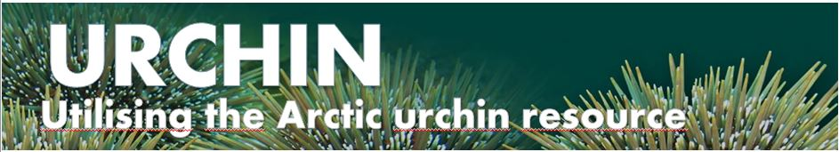

NPA URCHIN Project, Technical Workshop

Galway, Ireland,
7th of April, 2016

Location: Marine & Freshwater Research Centre
Galway Mayo Institute of Technology
Dublin Road, Galway, Ireland.

We are pleased to invite all interested parties to join us at the URCHIN project Sea Urchin Workshop in Galway where there will be a number of presentations from Irish and international researchers and industry representatives.

The theme of the workshop is dissemination of relevant information to all groups interested in sea urchin fishing, resettlement and roe enhancement. These include small and medium businesses, public authorities, business support groups and government and local authorities and NGO’s.

In addition to presentations from experts there will be plenty of opportunity for discussion and social mixing throughout the day and during the evening.

If there is sufficient interest there will also be a site visit to Dunmanus Seafoods in West Cork to see commercial production of juvenile urchins and roe enhancement and live urchin storage on the 8th of March, the day after the workshop.

If you would like to enroll, or would like any additional information please contact:

- Dr Colin Hannon, Galway Mayo Institute of Technology, Ireland
Phone: +35391742522
Email: colin.hannon@gmit.ie
- or, Dr Phil James, Nofima, Norway
(+47 48168263; philip.james@nofima.no)
Website: http://urchinproject.com

The final agenda will be distributed as soon as it is finalised.
We look forward to seeing you there!

